Lehman Flips: Techniques for a Hybrid classroom that are flipping instructional methods, reversing roles, and changing minds.
“Education should aim at long-lasting learning that forever alters our grasp of the world, deepening it, widening it, generalizing it, sharpening it.”

-Donald L. Finkel, Teaching with Your Mouth Shut

In Lehman’s “flipped” classrooms, exercises that used to be ‘home-work’ have shifted to the classroom leaving faculty free from the lecture approach to offer more student-centered instruction, personalized guidance and interaction…and while some might not be so quick to embrace the uncertainty of these types of methods, Finkel says that the disequilibrium that arises from the disruption of an ongoing interaction with our world is what motivates our and our students’ learning- “We are trying to do something and we have been stopped. We need to find our way around the obstacle and continue toward our goal. Suddenly we have become interested in solving a problem

In this presentation, a panel comprised of faculty and staff from Lehman College will be discussing the unique instructional methods they are using to literally ‘flip’ their hybrid classrooms: incorporating video production tools like Camtasia and VoiceThread, as podcast lectures; the CUNY Commons, wikis, blogs, discussion boards, ePortfolios, and online ‘docs’ for students to collaborate prior to class, and in the classroom, and audience response iClickers to heighten and stimulate collaboration, engage students and help determine levels of retention.

Once the planning and course structure that support the Web and in-person delivery have been discussed, nuanced and put in place, the technologies utilized are simple to learn and use. By our faculty’s own accounts, the methods have had a profound impact on teaching and learning. Faculty will discuss their methods, successes, and weigh in on the investment of time and resources debate.

As time is also a real-life constraint at the conference, our panel will itself be ‘flipping the traditional conference method’ too. Online and print materials and videos will supplement the information provided today and will be shared prior to, during and after the event.

- Esther Wilder, Professor, Sociology: Numeracy Infusion Course for Higher Education (NICHE)
- Limor Pinhasi-Vittorio, Associate Professor, Literacy Studies: An ‘un’Common Writing Collaboration: Writing Workshop in the CUNY Commons
- Rena Quinlan, Doctoral Lecturer, Biological Sciences: Purposeful blending in the sciences: iClickers in the Biological Science Classroom.
- Diane Auslander, Adjunct Assistant Professor, History: VoiceThread and Blackboard Meet: Blending Web 2.0 into online course delivery
- Polo Merguzhis Adjunct Lecturer, Economics and Business: Using Camtasia as Lecture Capture for Increased Student (and Faculty) Engagement
- Barry Murdaco, Adjunct Lecturer, Political Science: Blogger, VoiceThread, Wikis! Not just Web 2.0 hype
- Guest: G.D. Peters, Adjunct Lecturer, English Department: Using PoetryGenius in the classroom (Poetry Genius, Rock Genius, Rap Genius, News Genius)

Moderators:
Alyson Vogel, Associate Director, Online Education alyson.vogel@lehman.cuny.edu
Steve Castellano, Online Teaching and Learning Technology Specialist steve@lehman.cuny.edu

Because much if not all of our online course work is delivered asynchronously, how can we manage our hybrid courses to avoid the stragglers who can pull the discussion in a backward direction by their late or ‘barely-there’ participation? Ideally we want everyone in the class to be involved in the same discussion at approximately the same time. The following technology tools and techniques form the basis for supportive pedagogical practices that encourage students to become better learners, with inquiry centered activities and note-taking strategies that inspire a multiplicity of students to actively participate in class discussions. What follows is a brief description of our projects:
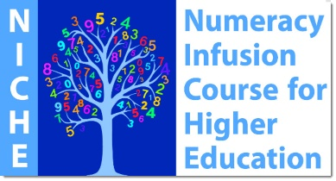
Numeracy Infusion Course for Higher Education (NICHE)
With support from a National Science Foundation (NSF) grant, Professor Esther Wilder as Principal Investigator is working with faculty at several institutions within CUNY who have developed a Numeracy Infusion Course for Higher Education (NICHE) to foster the blending of QR instruction and assessment into undergraduate courses into a broad range of disciplines.
Esther will discuss and demonstrate some of the blended strategies used to train faculty in how to effectively teach QR within a liberal education. QR skills enable students to participate effectively as professionals and citizens by becoming competent in the identification of quantitative evidence and using quantitative data for the solution of real-life problems. Materials for the course and further information on QR and QL are available at http://serc.carleton.edu/NICHE/index.html

An ‘un’Common Writing Collaboration: Writing Workshop in the CUNY Commons
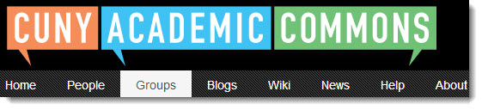
Professor Pinhasi-Vittorio has directed her Graduate-level Writing Workshop Course to the CUNY Commons, (a site developed and managed with the goal in mind to support faculty initiatives and build community through the use(s) of technology in teaching and learning). This hybrid writing workshop class puts emphasis on the advancement of collaborative writing skills through intensive writing, modeling, and multiple drafting in an online workshop context. Critical and comparative analysis of texts both given by the professor as well as generated by students, is used to foster academic as well as exploratory writing.

Moving her hybrid writing workshop online allows her students to focus on the advancement of writing skills through intensive writing, modeling, and multiple drafting using Buddy Press Docs, a group document editing feature similar to Google Docs that is available to users and groups of the CUNY Commons. Critical and comparative analysis of texts both given by the professor as well as generated by students are used to foster academic as well as exploratory writing, seamlessly blending online and in-person sections of the course

Purposeful blending in the sciences: iClickers in the Biological Science Classroom
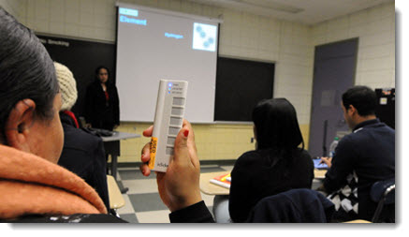
A clicker’ is an easy to use electronic multiple choice device that helps provide instant feedback on what students are learning. Professors create and display clicker questions via computer and projector, usually with Word document or PowerPoint slide. (Thanks to tech fee funds, at Lehman, every student in the class will have use of his/her own clicker that will be the same all semester, but units can be purchased individually.)

With each new traditional or hybrid class that is introduced to this technology we are finding that Clickers have been particularly useful for supporting critical thinking and empowering students to engage with and support their fellow classmates in group discussions large and small. Professor Rena Quinlan and Alyson Vogel, Associate Director of Online Education, will discuss how they have used clicker technologies to involve the entire class in dynamic interactive question-and-answer polling in a group setting. What clickers do provide is a way to rapidly collect an answer to a question from every student; an answer for which they are all individually accountable. This allows rapid reliable feedback to both the professor and the students with respect to the material being covered either in homework, in class or via online readings.

VoiceThread and Blackboard Meet: Blending Web 2.0 into online course delivery
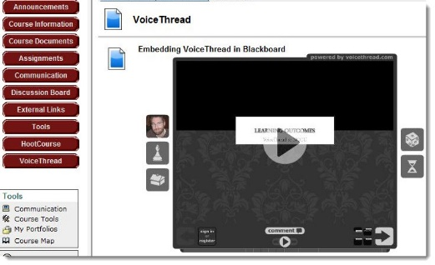
VoiceThread is integrated with Bb at Lehman! Teachers know it’s in their students’ and their own interests to design discussion topics that are so enticing, so intriguing and so well-directed that students won’t want to miss out— and several faculty at Lehman have been generating rich discussions on Blackboard and in VoiceThread that are used to launch media rich out-of-class discussions.
A teacher can create a Voicethread with minimal training, complete with prompts and questions that can guide students through the reading or online lecture. Then students follow up by taking to the virtual discussion boards and commenting via text, video, or document.

Adjunct Assistant Professor Diane Auslander will discuss her methods for creating guiding questions and topics which are often based on prior student responses, and illustrate how these creative forms of electronic discussion boards help her take the conversation to the next level in her hybrid classes. She will examine various uses for VoiceThread in the online classroom - both as a discussion forum and a lecture vehicle - as well as possibilities for expanded student access and usage. Presenters will demonstrate their individual usage through current classroom projects

Using Camtasia as Lecture Capture for Increased Student (and Faculty) Engagement
There are those professors and lecturers among us who believe that online teaching means taking away a big piece of their ‘in-person’ character and that online learning is static and has somehow managed to eliminate the professor from the teaching-learning equation. This segment does away with the myth that distance means disconnected: Participants will be provided insight on the knowledge gained from the alliance between Lehman’s Blackboard instructional technology specialist Steve Castellano, and Polo Merguzhis, Adjunct Lecturer and a dynamic professor of Economics and Business. Their project began with a common notion to help students remain engaged, retain concepts and gain deeper understanding of the material long after the ‘lecture’ part of the class was over. What resulted was a symbiosis between this core philosophy and acknowledgment among students of Professor Merghuzis’ ‘star’ power on video. This presentation will allow instructors to see how beneficial it can be to make creative and far-reaching modifications of their lectures.

The presenters will relate how quickly Polo was able to master a simple-to-learn program called Camtasia to enhance his hybrid class and to impact his students as well as heighten the professor’s presence in his online courses.

Blogging, Wikis! Not just Web 2.0 hype:
Social media are all the rage now, but
are they part of the Web 2.0 teaching revolution or are these tools merely 'flash' and 'gimmick'? What are some of the ways we can best implement them in the blended environment to offer meaningful learning experiences to benefit our students and ourselves as teachers? Barry Murdaco, along with several other of our faculty today dabble in these tools and think they get just the right 'blend'.

Barry will talk about his student’s role as creators of knowledge with his Blogger and Wikipedia projects and discuss what works well for his hybrid and online classes and will also clue us in on the nuances too. Attendees will gain from multiple experiences and hear about the highs as well as the lows to learn what works for them and what he learned *not* to do.

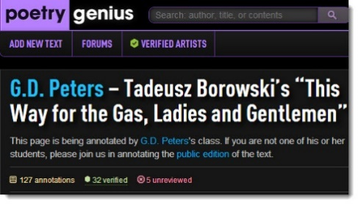
Using PoetryGenius in the Classroom
As has been written about it, “Rap Genius began as a rap lyric website, but it has since moved far beyond just rap, with unique home pages for Rock Genius, News Genius, and Poetry Genius. At its heart, Genius is a collaborative annotation platform. Like Wikipedia, it’s a crowd-sourced database that allows any users to add content. Unlike Wikipedia, Genius invites users to annotate documents, to break down and close read novels, short stories, poems, and a wide variety of other text."
For the past few semesters in his Business Writing class, G.D. Peters has been asking his students to present a brief oral report to the class on a recent business report (the Business Report-Report). Articles chosen must pertain to the curriculum or to the business world in general, and this tool became the motivational driver for displaying and annotating their articles. Students are emailing G.D. asking how they might best use the tool to expand their presentations, add video, etc. – Needless to say G.D. is thrilled by this response!

TO REGISTER FOR THE CUNY IT CONFERENCE SIMPLY GOOGLE CUNY IT CONFERENCE OR CLICK ON THE FOLLOWING LINK!
http://forms.erepublic.com/cde-event-registration-step1-default?contentID=201274161&r=EV-2384

Be sure to visit our website for information on this year’s conference entitled
*Embrace the Disruption, Expand the Classroom: Visions and Explorations
on the CUNY Commons. For updates and to register for the
2014 CUNY BronxTech Showcase: http://cuny.is/bronxedtech

